# An Ancient Greek Guide to Life: Aristotle, Epicurus, and Aesop

While nearly everyone would agree that they want to lead a “good” or “successful” life, most of us spend surprisingly little time actually *thinking* about what this entails. Of course, we might have certain catchphrases memorized (from favorite books, religious figures, old sayings, etc.), but these often play little role in what we actually *do*: the sorts of jobs we pursue, the friends (or romantic partners, or coworkers) we choose to spend time with, the way we spend the majority of our money or free time, and so on. In this lecture, we’ll be taking a look at some views on what the good life is. The goal isn’t so much to find any concrete answers as to get you *thinking* about it.

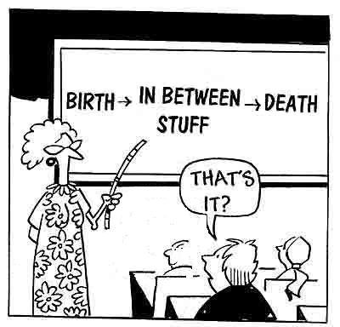

Before exploring philosophical theories of the good life, take some time to think about the following questions (adapted from a list by Robert Solomon):

1. Leaving aside basic necessities (for food, water, shelter, etc.), what do you consider to be the *most important* things in life? Spending time with family/friends? Helping those worse off? Working at an engaging job? Creating art? Spending time on leisure activities (which kind)? Travel? Acquiring stuff? Supposing that you had money to meet your basic needs, how would you allocate your time?
2. What sorts of *activities* bring you the greatest sense of happiness, joy, or personal satisfaction?
3. How do you determine which *people* to spend your time with? What do you look for in a friend, romantic partner, or coworker?
4. What kind of person do want to be by the time you are old? That is, what would it mean *for you* to be able to say to yourself “I led a good life”? What sorts of steps are you taking in the short, middle, and long-term to achieve this?

## Aristotle on Eudaimonia and the Good Life

“One swallow does not make a summer, neither does one fine day; similarly one day or brief time of happiness does not make a person entirely happy.” (Aristotle, Nicomachean Ethics)

**Aristotle** (384-322 BCE) is widely considered (along with his teacher, Plato) to be one of the most influential ethical theorists ever to have written. Among other things, his “virtue-based” conception of ethics heavily influenced the way future Greek, Roman, Christian, Jewish, and Islamic writers treated the subject. For almost 2,000 years (from 350 BCE to 1650 CE), Aristotle dominated European philosophy, science, logic, and ethics in a way that no thinker ever has since.

**Humans are the “rational animals.”** Aristotle’s study of biology (a discipline he’s often said to have founded) convinced him that all living things have a *purpose* or *function,* and that a *good* organism is one that fulfills its function. He thought plants’ function was to nourish themselves and reproduce, that animals’ function was to sense and move, and that humans’ function was *reason.* We humans are the “rational animals,” according to Aristotle. This theory has definite consequences for what it means to be *good* or *bad*: a bad plant (e.g., one that is too short to get access to sunlight) cannot nourish itself, while a bad animal (e.g., one that is injured, and cannot move) cannot move. A bad human, by contrast, is one who fails to lead a life according to reason.

**Eudaimonia as the only (reasonable) ultimate goal of life.** Humans pursue a variety of goals: making money, playing games, spending time with friends, and so. We value some of these goals **instrumentally** (because of what they “get” for us), others **intrinsically** (for their “own sake”), and some both ways. In end, though, Aristotle argued that the *ultimate* goal of human life is “true happiness” (or **eudaimonia***),* since we value this intrinsically, and never instrumentally. He notes that humans have differing views on what this is: some of us pursue physical pleasure, some pursue honor/success, and others pursue wisdom for its own sake. (In the end, Aristotle argues this final group has it right, in that they fulfill human’s natural function). There are, he notes, some exceptions to this general rule, such as those vicious people (we’d call them sociopaths) who value dominating others and causing them pain. However, Aristotle assumes (reasonably) that such people are fairly rare, and that there’s little point trying to talk sense into them. So, his discussion assumes that the reader (like most other humans) DOES want to pursue eudaimonia.

**The complex relationship between pleasure and eudaimonia.** Unlike both his teacher Plato and many of his later interpreters (particularly religious ones), Aristotle thinks that many pleasures (for good food, sex, money, etc.) really are good, at least when pursued in the right sort of circumstances. However, he argues that eudaimonia cannot be *identified* with pleasure, since we all know that there are some pleasures which harm us (e.g., drinking too much alcohol), and some genuinely worthwhile activities (e.g., behaving courageously during war) which don’t always feel too pleasant, at least for the unenlightened among us. For this reason, much of Aristotle’s ethics is focused on the way that we can “perfect” ourselves in order to bring about an alignment between “what feels right” and “what will bring true happiness in the long run.”

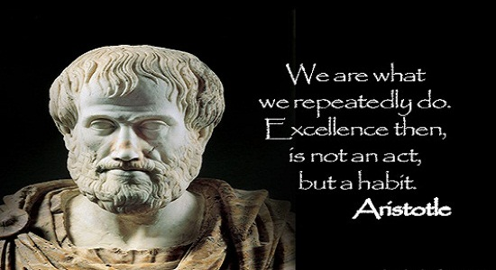**Some practical implications of Aristotle’s theory.** For Aristotle, achieving eudaimonia is above all a matter of consistent *practice.* So, for example, we have good evidence that people who consistently do things like maintain close friendships, volunteer in the community, exercise, eat healthily, and read books report higher levels of life satisfaction than those who don’t. However, one can’t become this sort of person overnight—in fact, the first few weeks of a new diet (or new exercise regimen, etc.) are often highly unpleasant. Aristotle recognizes this, but argues that this doesn’t mean “pain is good” or “everything fun is bad for you,” as people sometimes think. Instead, he thinks that we just need to practice living life the way we want to lead it (and without complaining!) until it becomes “second nature.”

## Epicurus’s Defense of Pleasure

“Don't fear the gods,/ Don't worry about death; / What is good is easy to get, and / What is terrible is easy to endure.” (Diogenes Laertius, Life of Epicurus)

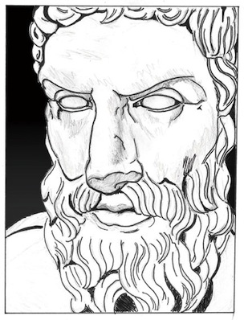**Epicurus** (341 to 270 BCE)lived in the generation immediately after Aristotle. His view of the world, and of what it means to lead a good life, is quite different from Aristotle’s:

* **There is nothing but atoms and the void.** Epicurus argued that, at bottom, everything was made of small pieces of matter called “atoms” that bounced around in the “void.” Everything else—humans, the gods (if they existed), animals, etc.—were simply collections of atoms. There were no immortal souls, and humans had no essential “purpose” or “function.” Humans were born, lived, and died, and the universe they inhabited didn’t “care” about them. Epicurus is sometimes said to have offered the first **problem of evil** argument against the existence of God, which claims that the widespread existence of suffering is incompatible with the existing with any sort of all-powerful who cares about humans.
* **The only good is pleasure, which must be pursued wisely.** Epicurus doesn’t agree with Aristotle’s idea that humans have a function. Because of this, he argues that humans ought to do whatever will bring them the most pleasure *in the long run.* However, this does NOT mean that humans should behave in rash or immoral ways. Instead, Epicurus thinks that the best way to be happy is to *limit one’s desires* and to *avoid activities that we know will lead to pain.* For Epicurus, the pursuit of luxuries gets in the way of what really makes us happy (which is mostly having conversations with close friends).
* **Some desires are good; some are not.** Epicurus argues that we can promote happiness best by trying to meet our *natural AND necessary* desires for things like food, shelter, friendship and so on. He warns against spending *too* much time pursuing *natural BUT unnecessary* desires (for fine food, sexually attractive people, etc.) which go beyond what we really need (and can lead to bad outcomes if pursued too far). Finally, there are some *unnatural desires* (for obtaining power, stockpiling money, or “life after death”) which simply CANNOT be fulfilled, since there is no “limit” on these things. Epicurus argues that, if you devote your life to pursuing these, you are bound to be miserable.
* **Modern influence.** Epicurus is often cited an early defender of a **naturalist** worldview (one without supernatural beings or forces), and his generally **utilitarian** ethics (focused on pursuing both your own happiness and the happiness of those around you) fits in well with this. For hundreds of years after his death, “Epicureanism” served as something of a secular “religion” in the Roman Republic and Empire. While Epicureanism died out with the rise of Christianity in 300 to 500 CE, the rediscovery of lost Epicurean texts a thousand years later played a role in helping to start the scientific revolution and in challenging Aristotelian notions of ethics and the good life.

In the end, Epicurus argues that much of our unhappiness is caused by the unrealistic goals we set for ourselves. We want to “keep up with Joneses,” and feel miserable when we see other people who have more stuff than we do. Epicurus says the *best* way to deal with is NOT to get more stuff, but to teach yourself to stop caring. Like Aristotle, he recognizes that this may not be easy at first, but he argues that it will pay off (in the long run).

## In Defense of the Grasshopper: Is Life a Game We are Playing?

*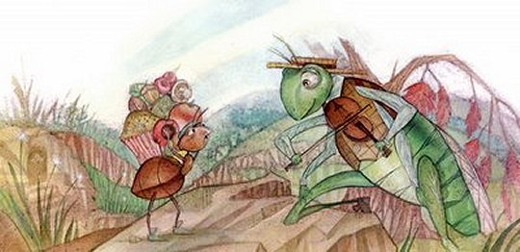In a field one summer’s day a Grasshopper was hopping about, chirping and singing to its heart’s content. An Ant passed by, bearing along with great toil an ear of corn he was taking to the nest.*

*“Why not come and chat with me,” said the Grasshopper, “instead of toiling and moiling in that way?”*

*“I am helping to lay up food for the winter,” said the Ant, “and recommend you to do the same.”*

*“Why bother about winter?” said the Grasshopper; “we have got plenty of food at present.” But the Ant went on its way and continued its toil. When the winter came the Grasshopper had no food, and found itself dying of hunger, while it saw the ants distributing every day corn and grain from the stores they had collected in the summer. Then the Grasshopper knew: “IT IS BEST TO PREPARE FOR THE DAYS OF NECESSITY.”* (Aesop’s Fables)

In the fable of “The Grasshopper and the Ant,” the ant works all summer to gather food for the winter, while the Grasshopper wastes his time singing and chirping. Predictably, the ant survives the winter, while the grasshopper starves. Aesop’s lesson is a straightforward one: those who work hard will flourish, while those waste their time will suffer. The fable is often read as a celebration of the **“work ethic”,** and about the long-term benefits of working hard.

In a book called *The Grasshopper: Games, Life, and Utopia,* the philosopher Bernard Suits provides adefense of the Grasshopper’s way of life (the book is actually written from the perspective of the Grasshopper). In particular, Suits suggests that the Grasshopper has realized a fundamental truth that Ant has missed: that life is a *game,* and the goal of life is to play the game *well.* The core of the argument is as follows:

* Suits defines a **game** as a “voluntary attempt to overcome unnecessary obstacles.” More specifically, he thinks a game is an activity with a *prelusory goal* that players must try to achieve using methods *(lusroy means)* allowed by the rules. The *constitutive rules* of the game specifically prohibit the fastest/most efficient way of achieving the goal. Finally, and most importantly, the *reason* that the players follow the rules is that *they want to play the game.* “Winning a game” (by achieving the prelusory goal) only matters because individual players have said that it does.
* For example, the goal of golf is to get the ball in the hole in as few strokes as possible. However, there are certain rules that must be followed (you must use golf clubs instead of your hand), and these rules prohibit the most efficient ways of achieving the goal (you can’t scream at your competitors to distract them, or knock out their kneecaps with a bat). Finally, the whole activity would be meaningless if people didn’t care about it. There is nothing inherently valuable or worthwhile about putting little white balls in holes; this becomes valuable only when people want to play the game of “golf.:

The Grasshopper’s realization is that, according to this definition, *life* is a game. Each of us is committed to achieving some goal or other: raising a family, getting rich, founding a business, writing a novel, etc. Moreover, we follow certain rules in order to do this: these might be the rules of morality, of a certain religion, of artistic integrity (no plagiarism!), or so on. These rules prohibit us from “cheating” to achieve our goal. Finally (and here’s the controversial part), the Grasshopper suggests that this goal (and these rules) has meaning *simply because we want to live a meaningful life* (we want to “play the game”). For the Grasshopper, unlike for Aristotle or Epicurus, there is no single “right way” to live, and no “deep truth” about the ultimate meaningfulness (or meaninglessness) of human life. Instead, our lives are (self-designed) games, where we need to choose both the goals we are aiming at, and the rules that we will follow to get there. The Ant’s mistake was to think that working hard would (all by itself) allow for a better life; the Grasshopper realizes that it is play (and not work) which gives life its value and purpose in the first place. (Of course, one might still recognize the long-term value in the Ant’s planning for the future, even if life *is* a game).

# Review Questions

1. **A thought experiment.** Suppose that a 90-year-old version of yourself was able to travel back through time and come to visit you right now. Do you think they would be satisfied with your choice of values, friends, jobs, etc.? What do you think their (your) biggest regrets would be? Their greatest points of pride/satisfaction?
2. **Favorite theory.** Which of the three theories we’ve covered (Aristotle, Epicurus, Suits) most closely approximates the way YOU find meaning in your life? Explain and defend your answer.
3. **Criticisms.** Each of the three theories (Aristotle, Epicurus, Suits) we’ve talked about has been criticized. Choose ONE of the following criticisms to expand on. Do you think this criticism works? Why or why not? (Make sure to defend your answer!)
   1. Aristotle’s theory incorrectly assumes that there is an “objective” purpose of human life. The idea that humans are “designed” to live in a certain way contradicts Darwin’s theory of evolution.
   2. Epicurus’s theory is wrong to claim that only goal of human life is “pleasure.” In fact, many people devote their lives to activities—raising children, doing art, helping the community—which are not pleasant.
   3. According to Suits’ theory that life is a game, there are no “better” or “worse” ways of living, so long as the particular person enjoys their life. However, this is false—there are obviously some ways of living that are better than others.

## References and Bibliography

* Aristotle. 2016. *Nicomachean Ethics (Abridged)*. Translated by Ian Johnston. Ian Johnston. <https://sites.google.com/site/brendanpshea/readings/aristotle_ethics>.
* Epicurus. 1925. *Principal Doctrines*. Translated by Robert Drew Hicks. MIT Classics Archive. <http://classics.mit.edu/Epicurus/princdoc.html>.
* “Epicurus | Internet Encyclopedia of Philosophy.” 2016. <http://www.iep.utm.edu/epicur/>.
* Konstan, David. 2014. “Epicurus.” In *The Stanford Encyclopedia of Philosophy*, edited by Edward N. Zalta, Summer 2014. <http://plato.stanford.edu/archives/sum2014/entries/epicurus/>.
* Kraut, Richard. 2014. “Aristotle’s Ethics.” In *The Stanford Encyclopedia of Philosophy*, edited by Edward N. Zalta, Summer 2014. <http://plato.stanford.edu/archives/sum2014/entries/aristotle-ethics/>.
* Suits, Bernard. 2015. *The Grasshopper - Third Edition: Games, Life and Utopia*. Broadview Press.